FNBE0115
CULTURE AND CIVILIZATION (CLS30105)

COUNTRY CHOSEN: PORTUGAL

GROUP MEMBERS:

LIM WIN KEE 0322790
YANG JING LOO 0323066
WEE SUE WEN 0322633
BRIAN KOH JUN YAN 0322002
LE JIA LING 0322532
KIU NGIN PERN 0322084
SERAJEDDIN ALI SULIMAN 0322399

PADLET : http://padlet.com/Portugal/n0d2l8q3j9up

Summary

From all the research that my group and I had done, we understood that Portugal is ruled by powerful and brave kings in the earlier centuries, such as King Alfonso VI of Leon and Castille and Afonso Henriques. Both of them are very brave to face every single war and almost success in every of it.

From our research, 12 – 14 centuries in Portugal is under House of Burgendy, which is found by Henry of Burgendy, the father of Afonso Henriques and the first husband of Teresa de Leon. Henry of Burgendy is a French nobleman, who helps King Alfonso VI of Leon and Castille to defeat the Moors and win the trust from the king. He married with the king’s daughter, Teresa de Leon, and only one of their child survived, which is Afonso Henriques.

The culture that we research on the most is the tradition Portuguese wedding as we have two wedding scenes in our video. During wedding, the bride usually wears black dress and white veil with jewellery. As the groom wear white shirt and black pants. After the exchange of wedding rings, the priest then put on his stole on both of them as a symbol of joining together of two souls.

For the social strata in the12 centuries in Portugal, the king or the ruler of the kingdom, such as King AlfonsoVI and Afonso Henriques will be in the highest column while the royal family, like Henry of Burgendy and Fernando Perez will be in the second column. Following by the priest and nobles, then vassals and knight. The commoners will be the lowest in pyramid which is farmer and slaves.

Last but not least, the costume that we made for our video is referring to the pictures of our characters. For the male costume, they usually wear a rectangular piece of cloth with a hole in it for the head.As the women, their clothing are modest and restrained, which is a floor length, loosely-fitted gown, with long, tight sleeves and a narrow belt was uniform. The costume of the royal family is almost similar but the main difference is the fabric used.

SCHOOL OF ARCHITECTURE, BUILDING & DESIGN
Research Unit for Modern Architecture Studies in Southeast Asia Foundation of Natural and Built Environments

CULTURE & CIVILIZATION (FDES 0815)
Prerequisite: None
Lecturers: Ida Marlina Mazlan, Sufina Abu Bakar

Project 2
Messages from the Past
30% marks (20% Group – 10% Individual) Submission date: 6th / 8th October 2015

Introduction

“The history of drama stretches back to some of mankind's earliest civilizations. It's always fun to learn the history of a play that you're watching. You could be seeing something that people have enjoyed for hundreds or thousands of years. Drama as we know it got its start back in ancient Greece. Many of the plays written during the Classical period, from 525 BC to 385 BC, are still performed today”

Objectives

- To examine the similarities and differences between Eastern and Western civilizations.

Learning Outcome

- Able to recall the development of Eastern and Western human civilizations in the past as well as present.
- Able to demonstrate good documentation and presentation skills.

Tasks

Part I: Timeline Research: You are to research and analyze the specific given timeline through books, and internet. Elements such as the culture, administration, social strata, tradition and history or myth are to be researched and included in the timeline. With the research that you have conducted in mind prepare a visual timeline. Select the most important plot from the timeline for your performance. The materials gathered are to assist you for your group and individual outcome.

Part II: Individually, your task is to study the character chosen in detail that would demonstrate your understanding of the chosen elements in Part 1. Final submission as a group would be a showcase of students’ understanding of the timeline and the 20mins showcase / acting of the scene of the elements that are prominent in the timeline.

Part III: Submission as an individual would be a journal on the character in A5 size comprises of series of sketches, colored, complete with annotations and design the packaging of your journals.

Submission Requirement Group

- Screening Date and Assessment Day**

Screening Date : 6th/8th October 2015 Venue : Class Venue
Time : Class Time

** For E-portfolio purposes,performance of each group need to be recorded and uploaded using proper media and compiled using a CD for lecturer’s archive.

- An A4 report* compilation comprises of Part I and Part III.

*List of report content will as below

Document your research findings and tutorials output in A4 size with a proper cover. (Includes, refer to details below). This shall be submitted on the same day of performance.

  - Assignment brief
  - Research – movies and characters that have inspired you, costume research, props research, etc.
  - A summary of your research and how you have adapted the research into your story.
  - A summary of your sketch.
  - A script of your sketch.
  - In each act in the script, pick the most crucial scene. Draw out that key frame (how you visualize that scene to be). You can draw with your own style.
  - All ideas of costumes and props must be drawn and colored. After they are completed, photographs are to be produced to show the final outcome.
  - References for both text and visuals.

Individual

- A5 booklet (maximum 6 pages). The journal includes brief introduction of character, progress of understanding and elements such as the culture, social strata, and architecture of the timeline.
- Journal works must be in hand drawn or collage format (No computer graphics).
- Referencing and citation of sources is to be inserted at the back of the culture journal.

Date : 6th/8th October 2015

Reminder: Works submitted late will yield 10% mark reduction. For works submitted later than two working days, no assessment will be done.
** Subject to changes (if any and will be announced in class)

Scene 1

Long ago in 1093AD, King Alfonso VI of Leon and Castille needed help after the defeat of all his troops against the Moors in the battle of Sagrajas.

Scene 2

Amongst the many nobles who came to the King’s aid only one was bravest and most daring, his name was Henry of Burgendy.

Scene 3

An alliance was soon established and together they rallied and retook Galicia and simultaneously defeated the Moors.

Scene 4

To show his gratitude King Alfonso VI gave as a reward the hand of his illegitimate daughter Teresa de Leon to Henry of Burgendy.

Scene 5

Years later amongst the many sons that Henry and Teresa have had only one survived into adulthood and that was the day on the 25th of July 1109AD when Afonso Henrique was born.

Scene 6

Soon after King Afonso VI appointed Henry of Burgendy authority and power to govern the region of Portugal

King Alfonso VI was69 when he died in the year 1109AD.

Scene 7

At the time dominion over the regions were unstable due to the royal family conflict within. This motivated Henry to seize the opportunity and declared Portugal an independent country.

Scene 8

Then on the 12th of May 1112AD Henry died from wounds during the siege of Astorga leaving Teresa de Leon to govern a country than by herself.
Being left the sole responsibility of such importance and gravity, Queen Teresa decided to expand on her new-found power and went to seek for allies.

Scene 9

On 1116AD Queen Teresa had remarried to the most powerful Galican nobleman, Count Trava, Fernando Perez hoping that the marriage would solidify Portugal’s alliance with Galicia.

Scene 10 & 11

And on 1116AD and 1120AD, she declared war against her half-sister the legitimate daughter to the King Alfonso of Leon and Castille in an attempt to seize a part of the Leonese territory.

On 1121AD Queen Teresa lost to her sister Queen Urraca and surrendered. However, instead of executing Teresa, they agreed to set her free under the condition that Portugal would be part of the Kingdom of Leon.

Scene 12

Soon after in 1128AD the Archbishop of Braga along With the main Portuguese feudal nobles were growing tire with Portugal’s alliance with Galicia. During existed competing rivalries between the Archbishop of Braga and the Archbishop of Galicia on popularity and influence amongst the people.

Scene 13

Sensing this to be a problem the Archbishop of Braga waited until Afonso Henrique turned 14 and convinced Afonso to rally a rebellion consisting of the Archbishop of Braga and the rest of the feudal nobles who were opposed to alliance with Galicia.

Scene 14

After gathering a strong enough force in numbers the rebelliondeclared war against Queen Teresa de Leon and her lover Fernando Perez at the battle of Sao Mamede.

Scene 15 & 16

The bloody battle that followed lasted long but the rebellion were victorious in the end. Then on 1129AD while proclaiming himself “Prince of Portugal”, Afonso Henrique exiled his mother to Galicia until death and took over ruling of Portugal.

Scene 17 & 18

After which came the many long years where Afonso would fight in many more battles against the rest of the Moors and other neighbouring hostile invaders.

Finally in 1139AD he was unanimously proclaimed “King of Portugal” by his soldiers after having attained a massive victory against the Moors at the battle of Ourique.

Scene 19

This is the legacy of the First King Of Portugal

King Alfonso VI of Leon and Castille
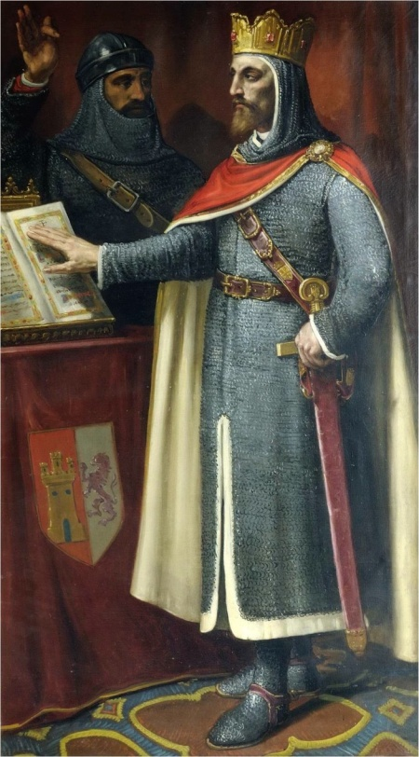

Birth : 1043
Death : June 30, 1109
Place of Birth : Braga, Portugal
Relation : -
- Father of Theresa of Leon and Queen Urraca
- Grandfather of Afonso Henrique
Character :
- Powerful and brave
- Passed away after appointed Henry to rule the kingdom.

Afonso Henriques

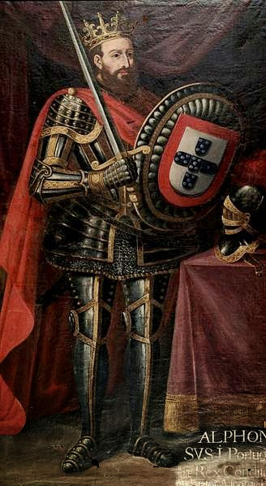

Birth : November 1109
Death : December 6, 1185
Relation : -
- Grandson of King Alfonso Vl of Leon and Castile
- Son of Henry of Burgendy and Theresa of Leon
Character :
- First king of Portugal (1139 – 1185)
- Involved in the Battle of Sao Mamede
- Secured Portuguese independence from Leon

Henry of Burgendy
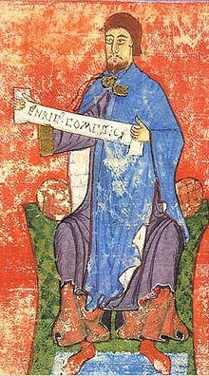

Birth : March 1066
Death : May 12, 1112
Place of Birth : Dunchy of Burgendy
Relation : -
- Son-in-law of King Alfonso Vl of Leon and Castile
- Wife of Theresa de Leon
- Father of Afonso Henrique
Character :
- Took responsibility of government
- Powerful, Brave

Teresa de Leon
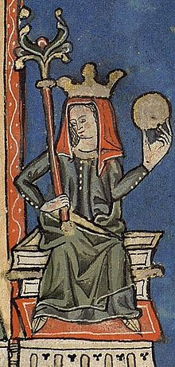

Birth : 1083
Death : November 1, 1130
Place of Birth : Braga, Portugal
Relation : -
- Daughter of King Alfonso Vl of Leon and Castile
- Mother of Afonso Henrique
- Husband :
> French Nobleman, Henry of Burgundy
> Galician Nobleman, Fernando Perez, Count of Trava
Character :
- Took responsibility of government after Henry died
- Fight with Queen Urraca in 1121 and lost
- Involved in the Battle of Sao Mamede

Queen Urraca

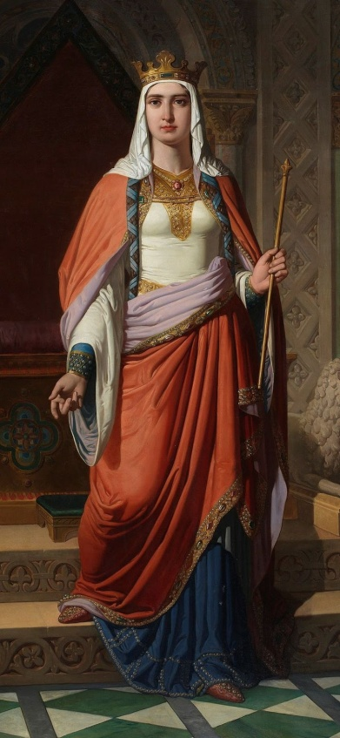

Birth : April 1079
Death : March 8, 1126
Relation : -
- Daughter of King Alfonso Vl of Leon and Castile
- Husband :
> Raymond of Burgundy
> Alfonso I of Aragon and Navarre
Character :
- Fight with Teresa de Leon in 1121 and win

Fernando Perez

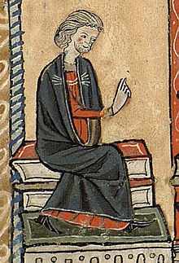

Birth : 1090
Death : 1155
Relation : -
- Husband of Theresa of Leon
Character :
- Smart, power and brave
- Involved in the Battle of Sao Mamede

Archbishop of Braga

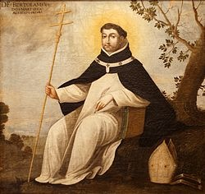

Birth : 1075
Death : 1137
Status : Archbishop of Braga from 1118 - 1137
Relation : -
- Advisor toAfonso Henrique
Character :
- Smart, power and brave
- Involved in the Battle of Sao Mamede

King Alfonso VI of Leon and Castille (Sew the fabrics and tie on the cape)

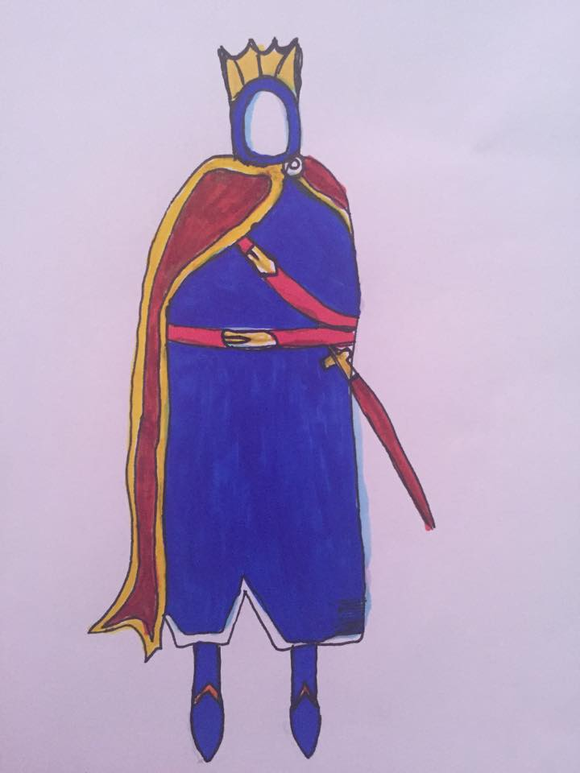

Afonso Henriques (Cardboard to make the armors and tie fabric for the cape)
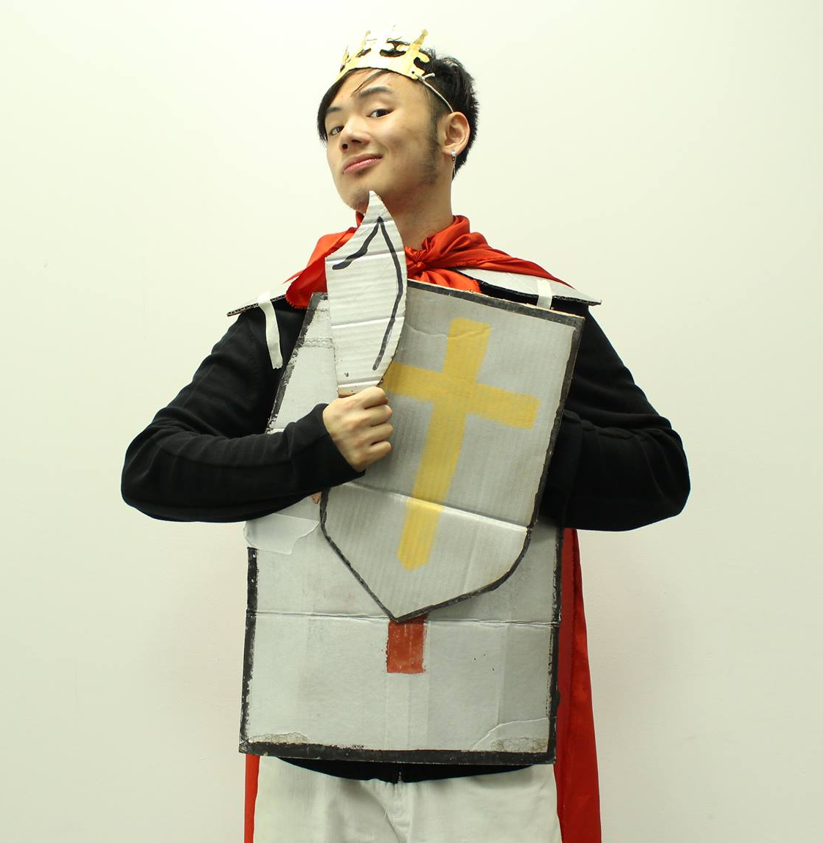
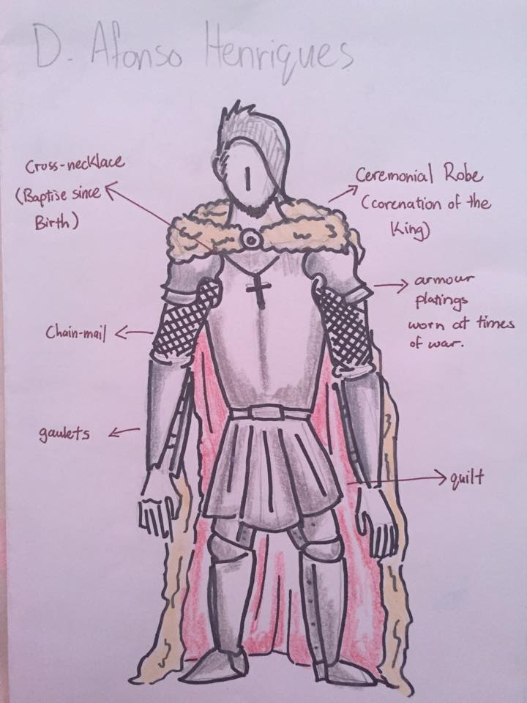
Henry of Burgendy (Sew fabric and tie on the cape)

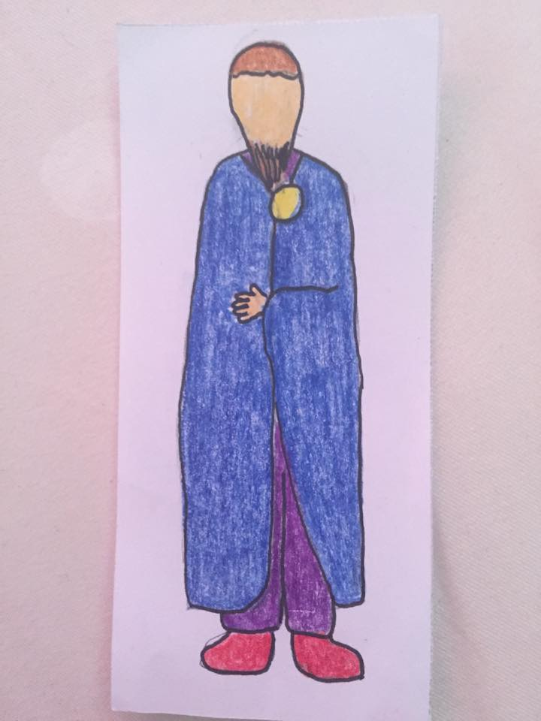

Fernando Perez (Wear red shirt inside and sew the black fabric)

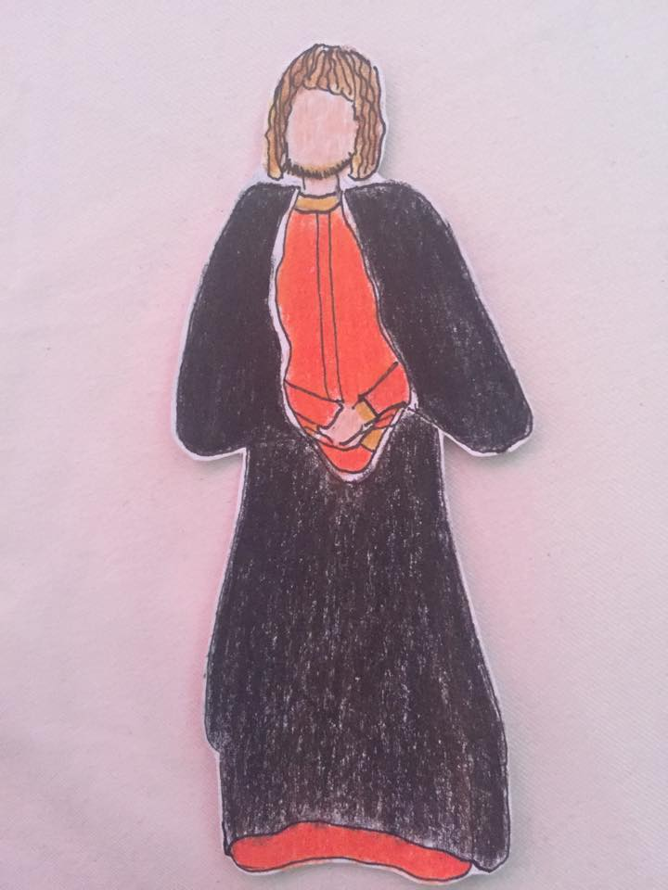
Teresa de Leon (sew the fabric and wear a black coat)

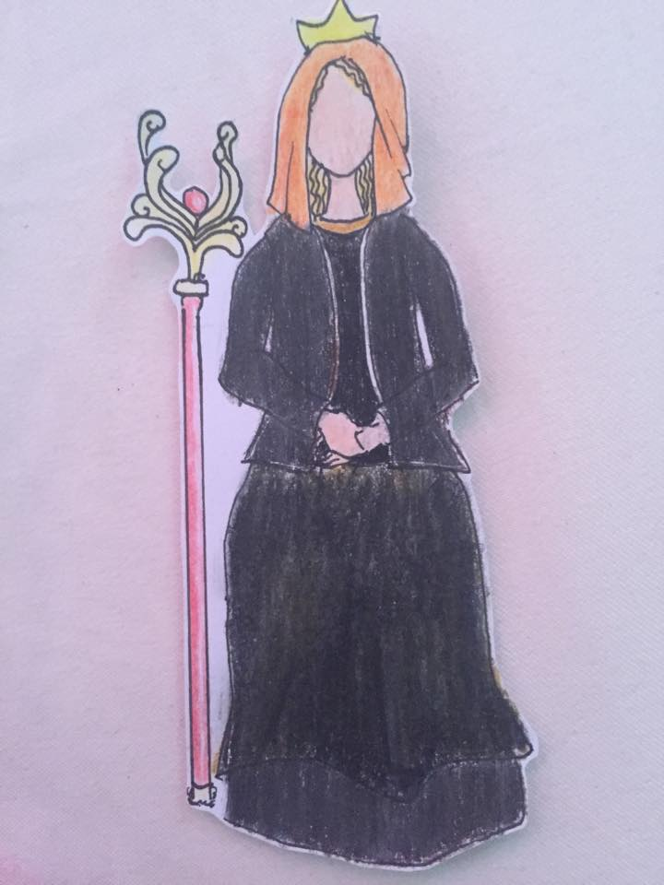

Queen Urraca (Wear white shirt inside andpin on the fabric by using safety pins)
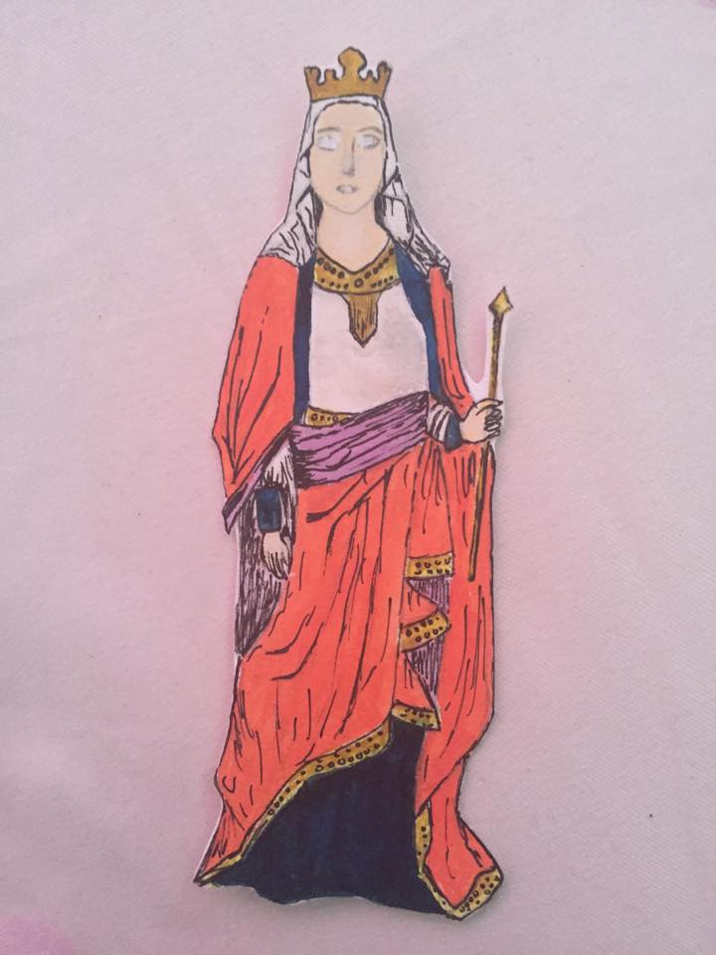
Archbishop of Braga (Sew the fabric and tie on for the cape)
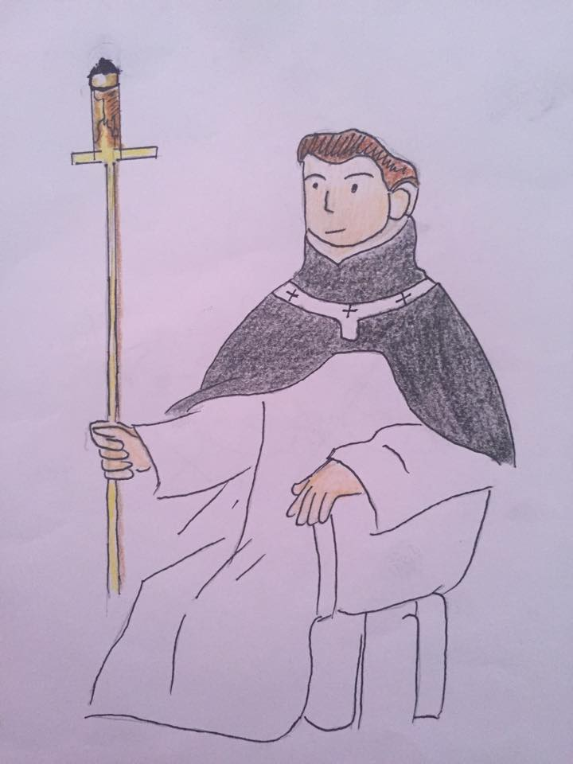

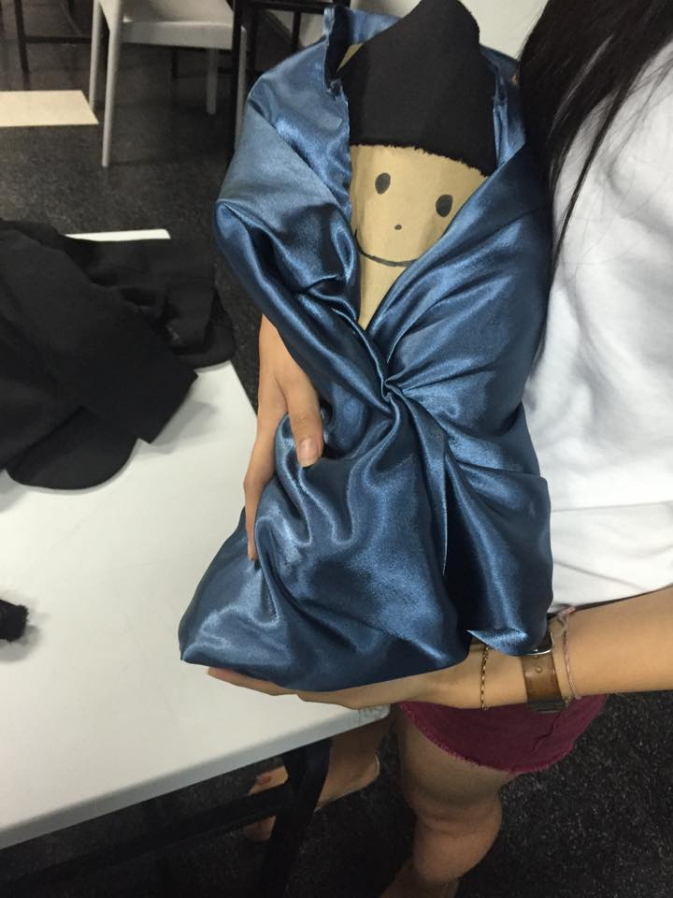
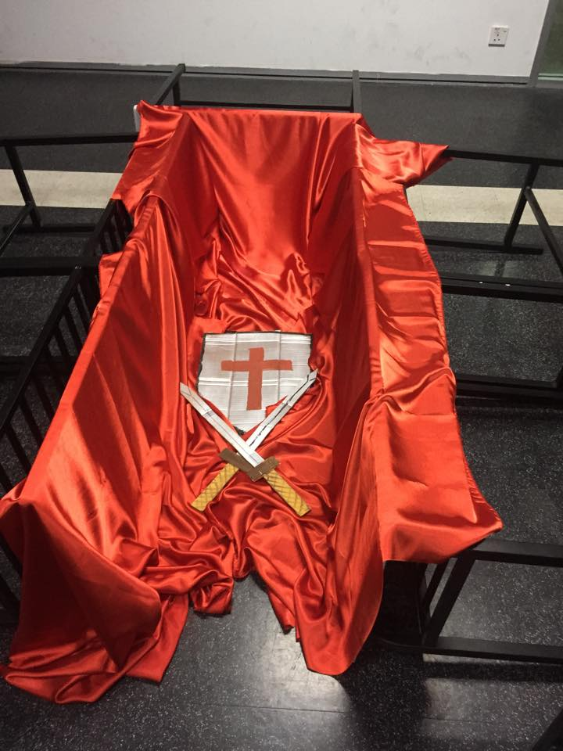
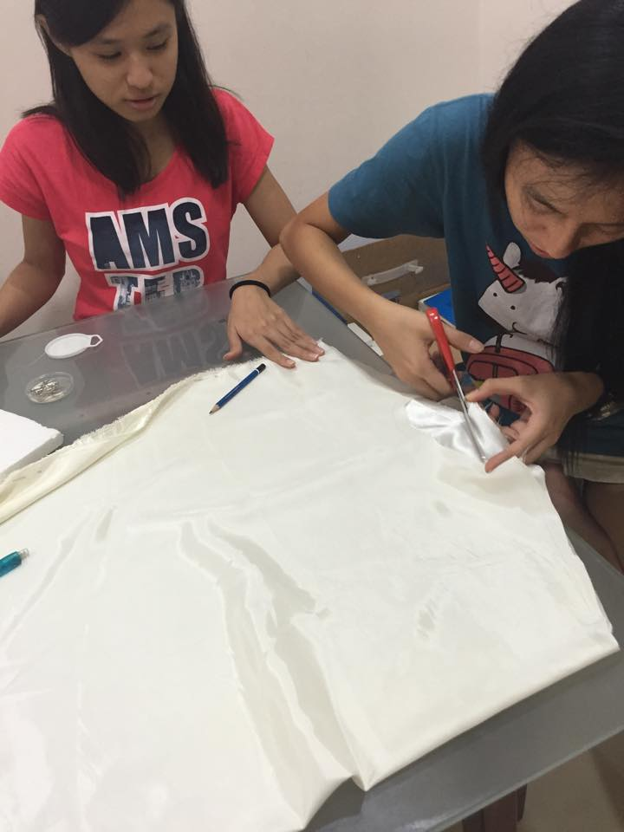
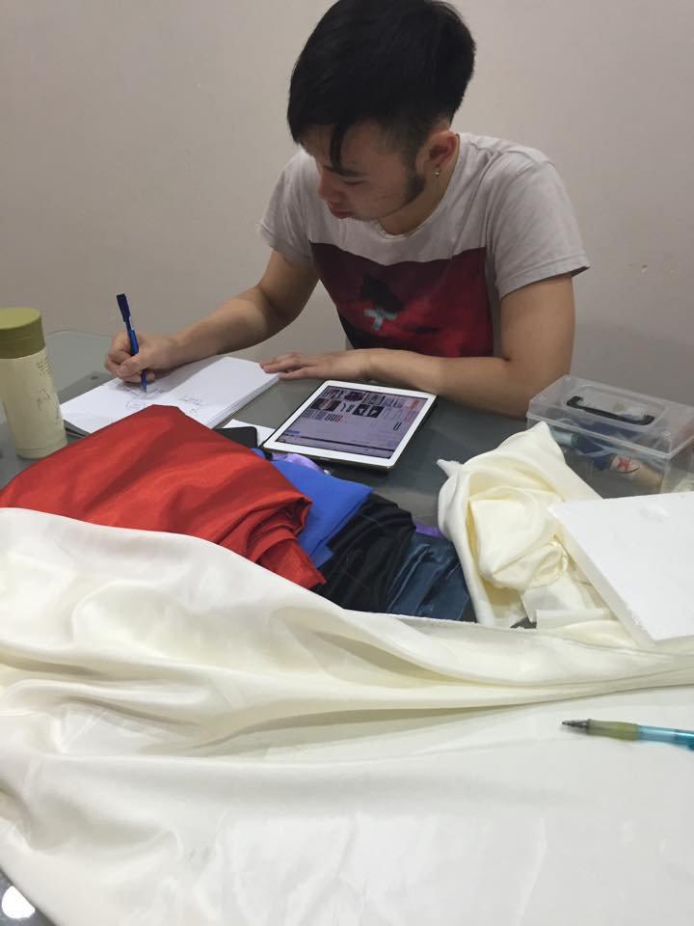
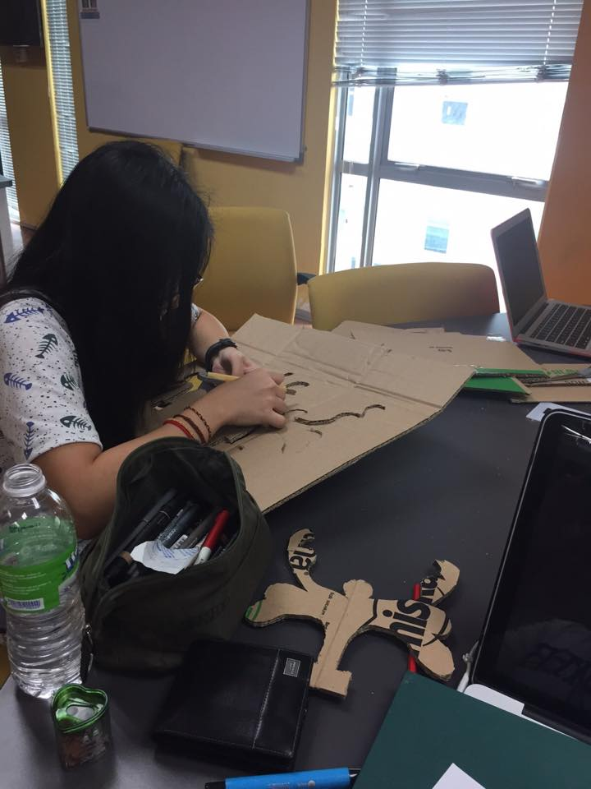
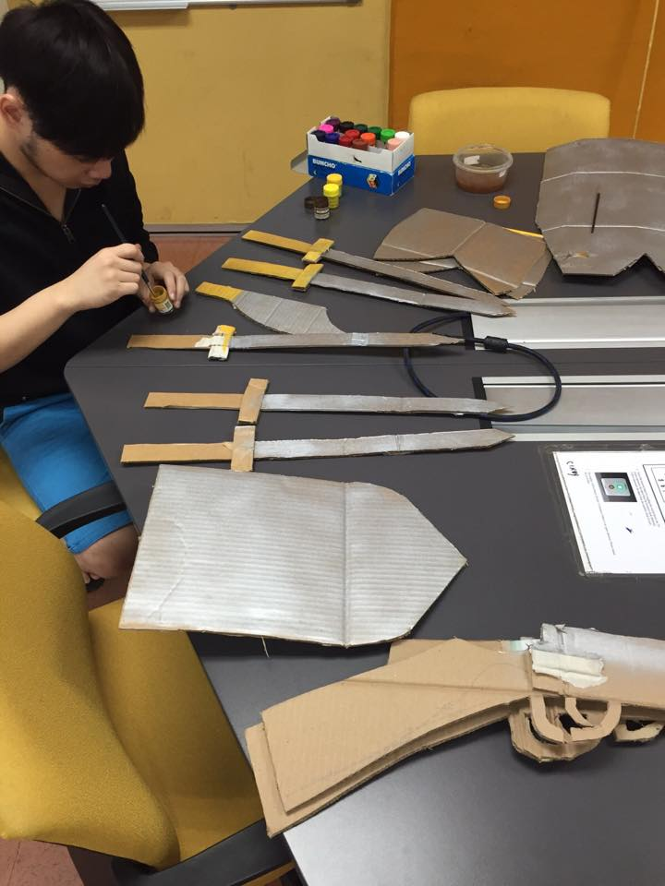
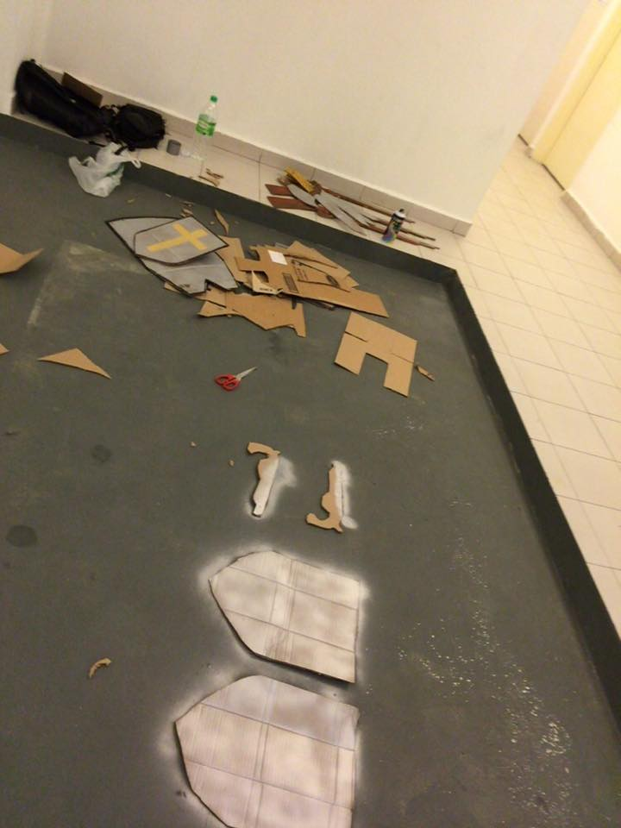
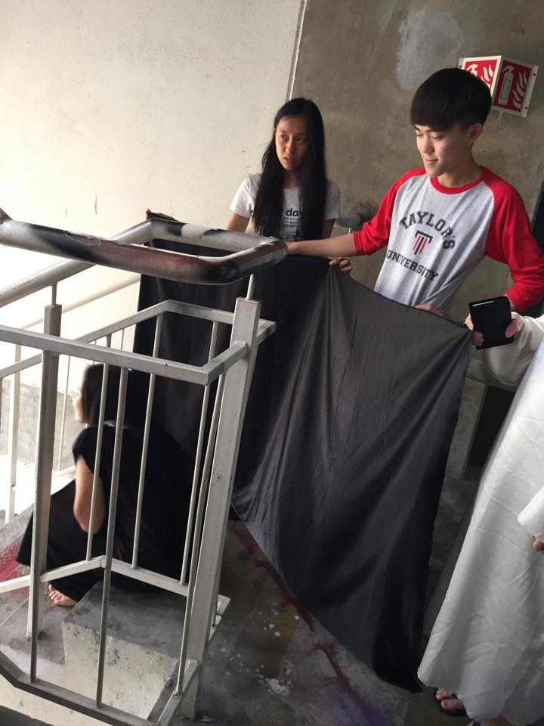

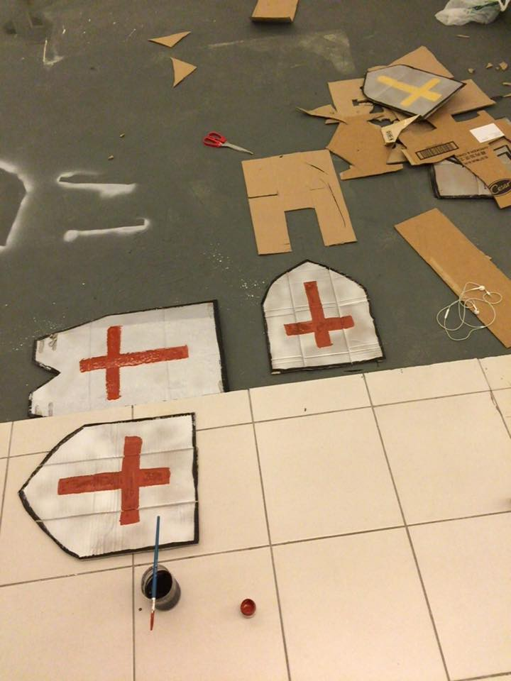
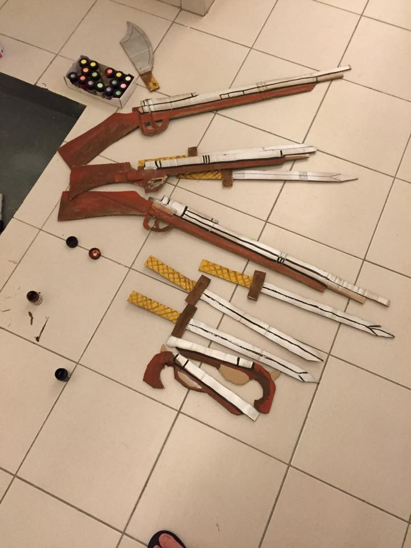
Guns, Swords and Armors (Cardboards, paints and spray)

Royal Mace (Bamboo sticks and cardboards)

