SITE ANALYSIS
Micro Climate
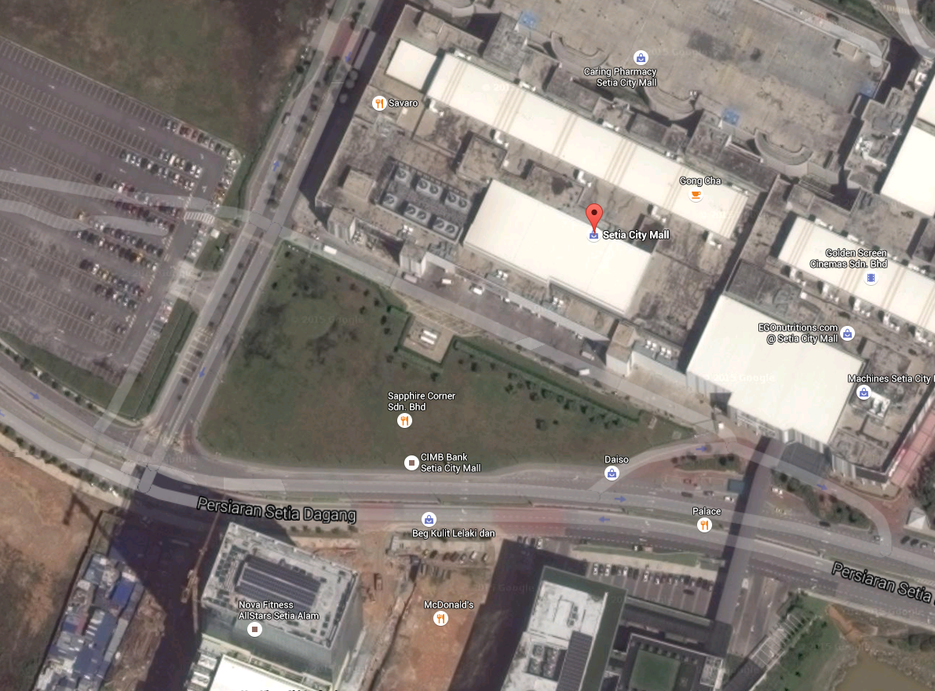
Figure 1. Micro Climate @google maps
Sun Direction
Wind Direction

-As you can see, the sun rise from the east side and sets at the west side of the proposed area
-It is observed that the wind is blowing to the south-east direction
-The average temperature at the proposed area is 28 degrees, slightly higher than the average temperature in Malaysia as it is situated in an urban area
-The average rainfall at the proposed area is 2400 mm
-The rainy seasons at the proposed area is from November to February

Circulation and Links

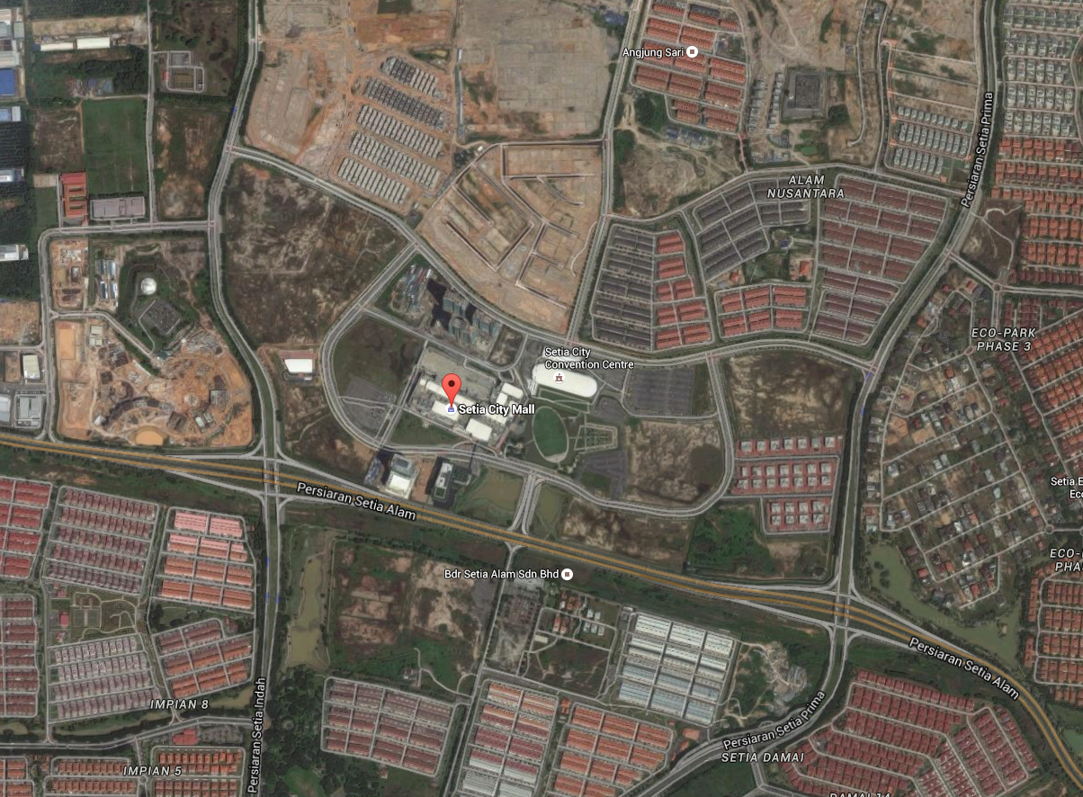
Bus Station
From Klang
From NKVE
From Jalan Meru
Figure 2. Circulation and Linkages @google maps

-According to the map, the proposed area can be access, from the west, Jalan Meru; from the east, New Klang Valley Express Highway (NKVE); and from the south, Klang.
-In the middle is the Persiaran Setia Alam which serves the main road to connect the outside world with the proposed area
-The proposed area can also be access by bus as there is a bus station nearby it

Existing Infrastructure

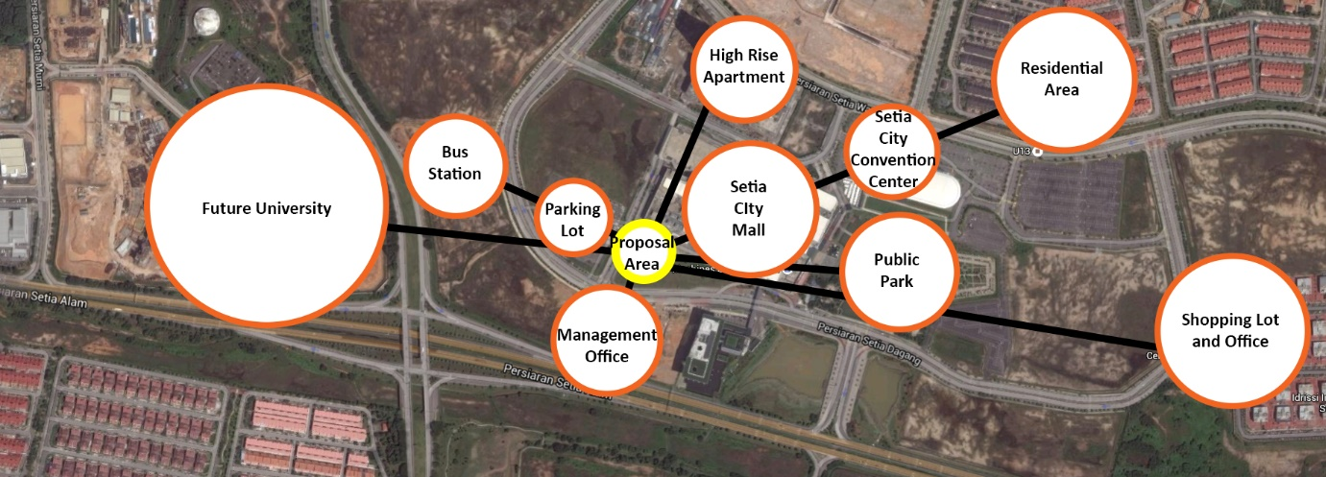
Figure 3. Existing Infrastructure @google maps

-Near the proposed area, there is a high rise apartment and residential area for accommodation
-There is also a Setia City Mall, Setia City Convention Centre, and Public Park for leisure activities
-There is a future university, shopping lot and office, management office
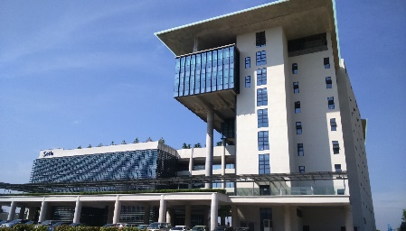
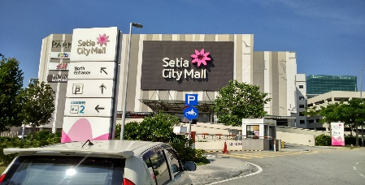
-For transportation, there is a bus station and a parking lot
Figure 4 Management Office
Figure 5 Setia City Mall
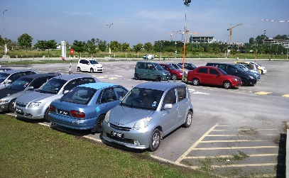
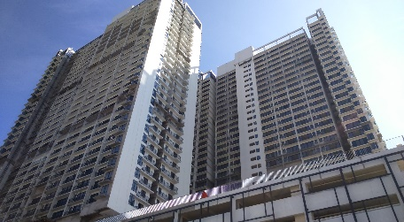
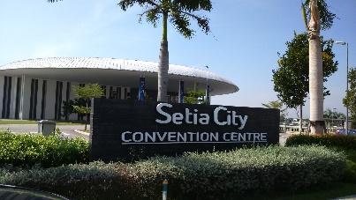
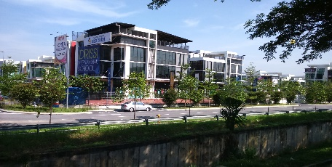
Figure 6 Parking Lot
Figure 7 High Rise Apartment
Figure 8 Convention Centre
Figure 9 Shopping Lots

